Neutral competition boosts chaos in food webs

Pablo Rodríguez-Sánchez[1]

Egbert H. van Nes[2]

Marten Scheffer[3]

[sec:Abstract] Near-neutrality of competition has been proposed to facilitate coexistence of species because it slows down competitive exclusion, thus making it easier for equalizing mechanisms to maintain diverse communities. An unrelated line of work has shown that chaos can promote coexistence of many species in super-saturated communities. By analyzing a set of numerically simulated food webs, here we link those previously unrelated findings. We show that near-neutrality of competition at the prey’s trophic level, in the presence of interactions with natural enemies, increases the chances of developing chaotic dynamics and we show that this results in a higher biodiversity. Our results suggest that near-neutrality may promote biodiversity in two ways: through reducing the rates of competitive displacement and through promoting non-equilibrium dynamics.

*Manuscript type*: article.

*Keywords*: coexistence, competition, neutral competition, biodiversity paradox.

*Manuscript elements*: 5 figures, 1 table, 1 online appendix (including 5 figures).

*The authors wish to be identified to the reviewers.*

# Background

Ever since Darwin, the idea that species must be sufficiently different to be able to coexist is deeply rooted in the history of biological thinking. Indeed, the principle of competitive exclusion (Hardin 1960) is intuitively straightforward, and elegant mathematical underpinning (**???**) helped making the principle of limiting similarity one of the cornerstones of ecological theory. Nevertheless, on a closer examination, natural communities often seem to harbor far more species that may be reasonably explained from niche separation. Plankton communities, where many species coexist with little room for differentiation, have served as an early example (Hutchinson 1959, 1961), inspiring the legendary ecologist G. Evelyn Hutchinson to ask the simple but fundamental question *"why are there so many kinds of animals?"* (Hutchinson 1959). Since then many mechanisms have been suggested that may help similar species to coexist. As Hutchinson already proposed himself, fluctuations in conditions may prevent populations to reach equilibrium at which species would be outcompeted. Also, natural enemies including pests and parasites tend to attack the abundant species more than rare species, and such a *"kill the winner"* (Winter et al. 2010) mechanism promotes diversity by preventing one species to take all the resources and outcompete the rest.

In the extensive literature on potential mechanisms that could prevent competitive exclusion there are two relatively new ideas that radically differ from the rest and have created some controversy: neutrality and chaos. The neutral theory of biodiversity introduced by Hubbell ((2001)) proposes that species that are entirely equivalent can coexist in a neutral way because none is able to outcompete the other. The concept of completely equivalent species has met skepticism as it is incompatible with the idea that all species are different. However, it turns out that also *"near-neutrality"* arises robustly in models of competition and evolution and may boost the chances for coexistence (Scheffer and Nes 2006; Scheffer, Nes, and Vergnon 2018; Fort, Scheffer, and Nes 2009; Fort, Scheffer, and Van Nes 2010). Support for such near-neutrality has been found in a wide range of communities (Scheffer and Nes 2006; Vergnon et al. 2013; Scheffer et al. 2015; Segura et al. 2013; Vergnon, Nes, and Scheffer 2012). The second relatively new and controversial mechanism that may prevent competitive exclusion is *"super-saturated coexistence"* in communities that display chaotic dynamics (Huisman and Weissing 1999). This is in a sense analogous to the prevention of competitive exclusion in fluctuating environments, except that deterministic chaos may arise in autonomous non-linear systems without any external fluctuation. Although there has been much debate about the question whether such internally driven complex dynamics plays an important role in ecosystems, several studies support the idea that chaos can be an essential ingredient of natural dynamics (Armstrong and McGehee 1980; Huisman and Weissing 1999; Benincà et al. 2008; Dakos et al. 2009).

Intuitively, it seems not likely that chaos and neutrality can be related, as fully neutral ecosystems can’t be chaotic. But natural ecosystems are never perfectly neutral, and predators may have a preference for different species. In the present work, we used a multi-species food-web model to explore the effect of near-neutrality at the prey level on the probability of developing chaotic dynamics. We found a surprising relationship between both ideas: the closer to neutrality the competition is, the higher the chances of developing chaotic dynamics. Additionally, our results confirmed that there is a positive relation between cyclic or chaotic dynamics and the number of coexisiting species.

# Methods

## Model description

We focused our attention on food webs with two trophic levels, one of consumers and another of prey. The consumers predate on the prey, and the prey populations are subject to implicit competition.

The dynamics were modelled using the Rosenzweig-MacArthur predator-prey model (Rosenzweig and MacArthur 1963), generalized to a higher number of species (see Nes and Scheffer (2004)). Our model contains prey species and predator species. The prey’s populations are under the influence of both intra and interspecific competition, whose intensities are coded in the competition matrix . The relative preference that predators show to each prey is coded in the predation matrix . In the absence of prey, the predators’ populations just decay exponentially. Prey immigration from neighboring areas has been added to the classical model in order to avoid unrealistic dynamics, such as heteroclinic orbits giving rise to long-stretched cycles with near extinctions (Nes and Scheffer 2004). In mathematical notation, the system reads:

where represents the biomass of prey species at time and the biomass of predator species at time . The symbol is used as a shorthand for the vector . The auxiliary functions and (see equations [eq:LogisticGenerator] and [eq:HollingGenerator]) have been respectively chosen to generalize the logistic growth and the Holling type II saturation functional response (Edelstein-Keshet 2005) to a multispecies system when inserted into equation [eq:SystemUnderStudy].

For details about the parameters used, please refer to subsection 2.2.

## Parameterization

We parameterized our model as a freshwater plankton system based on Dakos’ model (Dakos et al. 2009). Dakos’ model uses a Rosenzweig-McArthur multi-species model with two trophic levels, and parameterizes it to describe a zooplankton - phytoplankton system. Unlike Dakos, who uses seasonally changing parameters, our parameters were assumed to be independent of time (see table [tab:Parameters]).

### Competition and predation matrices

Our main purpose is to analyze the effect of different competition strengths on the long term dynamics exhibited. In order to simulate and quantify this heterogeneity, we introduce the competition parameter . This dimensionless parameter was used to build a competition matrix , whose diagonal terms are identically , and whose non-diagonal terms are drawn from a uniform probability distribution centered at and with a given width (here we chose ). Defined this way, the parameter allows us to travel continuously from strong intraspecific () to strong interspecific competition (), meeting neutral competition near . Two ecosystems with the same competition parameter, despite not being identical, will exhibit the same competition type. For the rest of this paper, we will call *neutral-on-average* those ecosystems with (see figure 1).

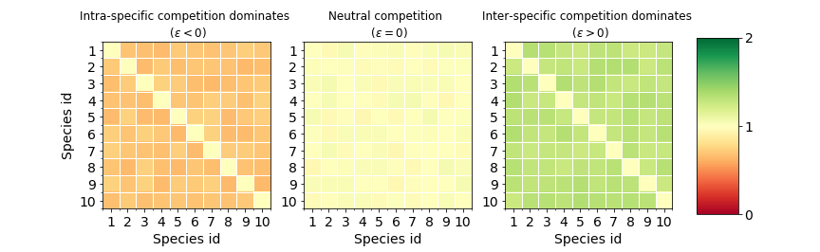

The competition matrix on the left is a clear case of dominant intraspecific competition. The central one represents a case of neutral-on-average competition. The matrix in the right panel shows a case of dominant interspecific competition. The difference between them is the relative size of the non-diagonal elements respective of the diagonal ones. This property of the competition matrices is controlled by the competition parameter .

Regarding the predation matrix , we proceed as in Dakos et al. (2009) and draw each of its coefficients from a uniform probability distribution bounded between and .

## Numerical experiment

Depending on the parameters and initial conditions, a system like the one described in equation [eq:SystemUnderStudy] can give rise to three types of qualitative behaviour, each of them roughly corresponding to a different type of attractor (see figure 2). The first one, a stable point attractor, generates a constant species composition. Secondly, limit cycle (and limit tori) attractors give rise to periodically (or quasiperiodically) changing species composition. Lastly, we’ll refer as chaotic to attractors that, while remaining bounded, do not fit in any of the previous categories.

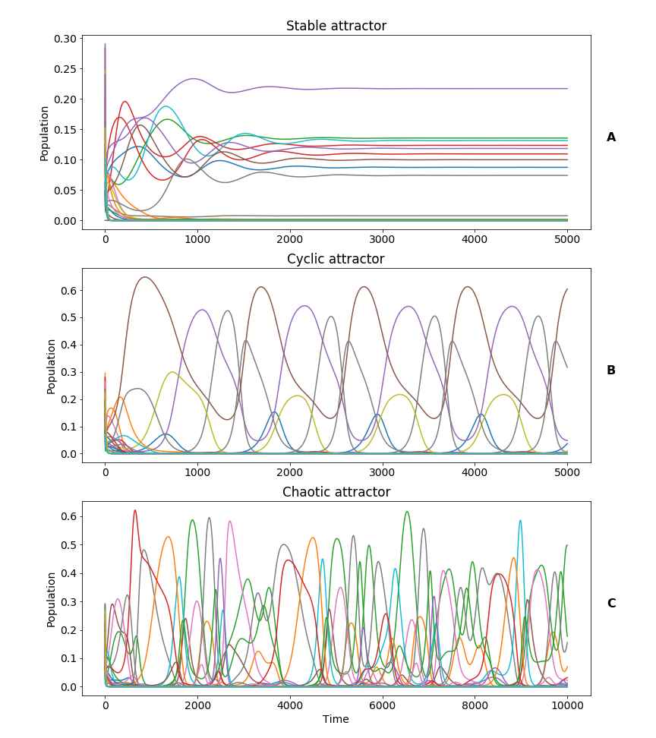

Our family of models generates time series of the population of each species. The time series can be classified in qualitative types depending on their asymptotic behaviour: stable, cyclic and chaotic. In **panel A**, the system reaches a stable attractor after a transient time. In **panel B**, a periodic attractor, with an approximate period of 1000 days, is reached after the transient time. The system in **panel C** never reaches a stable nor a cyclic attractor, but a chaotic one.

Our target is to estimate the probability of reaching each type of attractor under different assumptions about competition. In order to achieve this, we swept among different values of the competition parameter (defined in section 2.2.1), from to . The lower value was chosen to assure that the non-diagonal competition matrix elements can never be very close to zero, so our network remains always connected. The upper value was motivated by symmetry with the lower one. For each of the values of our competition parameter, different predation and competition matrices were drawn from the probability distributions described in section 2.2.1. Together with equation [eq:SystemUnderStudy] each of those parameter sets represents an ecosystem. We used standard numerical methods to solve each realization of equation [eq:SystemUnderStudy] and, thus, simulating the corresponding ecosystem. A first stabilizing run of days was executed in order to get closer to the attractor. Simulating for more days, we obtained time series in the vicinity of this attractor.

We used the Gottwald - Melbourne test (see Gottwald and Melbourne (2009)) to classify each of our time series as *stable*, *cyclic* or *chaotic*. The ratio of attractors found to be chaotic can be used to estimate the probability of a given family of ecosystems to develop chaotic behaviour. The probabilities of stable or cyclic behaviour can be estimated analogously. Additionally, two different measures of biodiversity were applied to each simulated ecosystem: the average number of non-extinct prey species and the average biomass grouped by trophic level. We considered a species to be extinct when their population density remained below a threshold of after the stabilization run. We determined the relationship between the competition strength, the probability of each dynamical regime and the biodiversity.

The numerical experiment was repeated for food webs of different sizes, ranging from a total of to species. In our simulations, we kept a ratio of 2:3 for the number of species at the consumer and the prey level.

In the spirit of reproducible research, we made available the code used to obtain our conclusions and generate our figures (Rodríguez-Sánchez 2018).

# Results

From figure 3 (see also figure 6 in the Online Appendix) we conclude that, in our model, the likelihood of chaotic dynamics reaches an optimum for near-neutral competition at the prey level. This result remains true for systems with a different number of species. The likelihood of chaos also increases with the size of the food web. This effect should not be surprising: the more dimensions the phase space has, the easier is to fulfill the requirements of the complex geometry of a chaotic attractor (Strogatz 1994). Even in those higher dimensional cases, there is still a clear maximum at neutral-on-average competition. The probability of chaos shows another local, lower maximum for weak competition coupling. We consider this a reasonable result, as predation is known to be the main driver of chaos in this kind of models (Nes and Scheffer 2004).

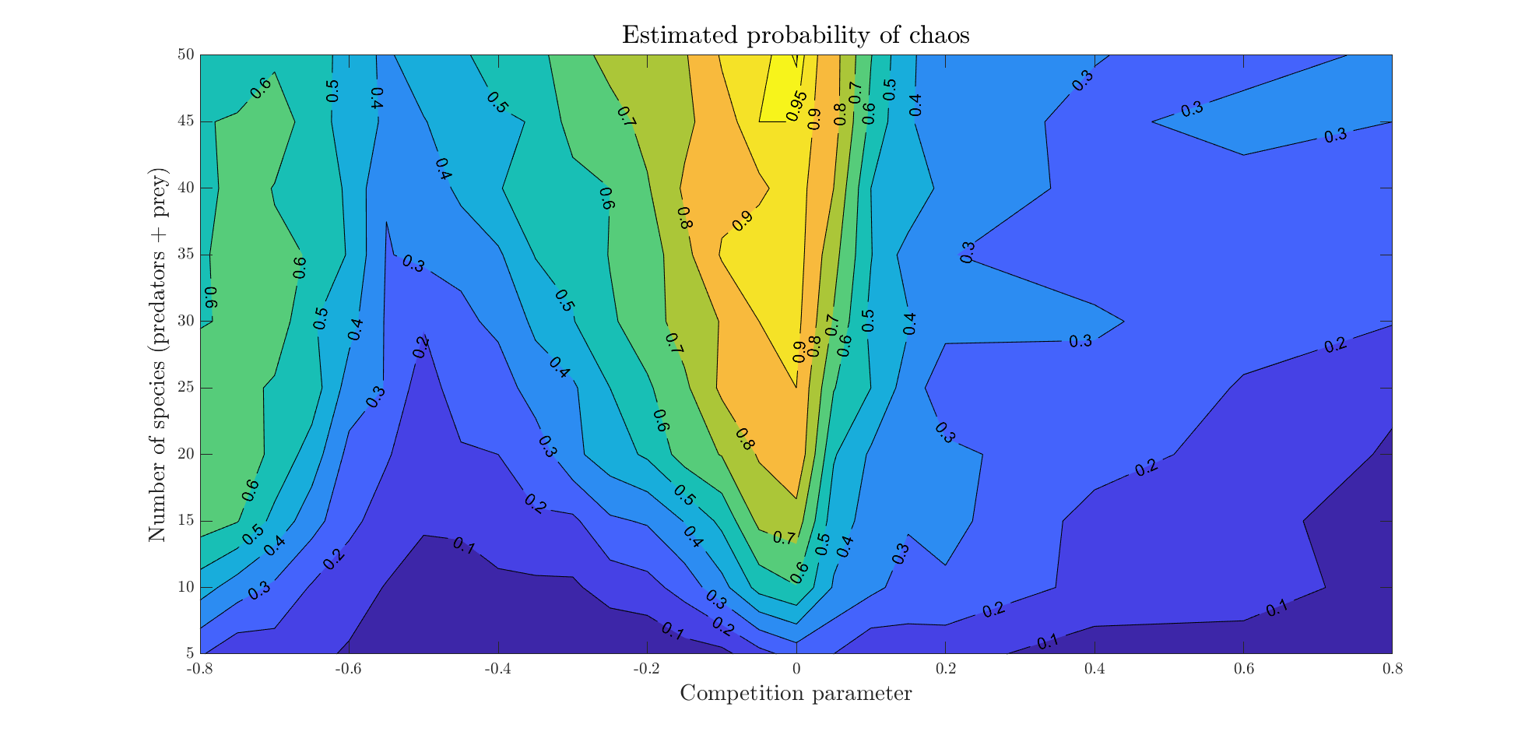

Contour map showing the probability of chaos for various competition parameters (horizontal axis) and number of species (vertical axis). The consumers’ population is fixed as of the prey’s population. Notice that chaotic attractors appear more easily (i.e., for smaller systems) the closer is the competition to neutral (i.e., ).

Indeed there seems to be a clear relationship between the probablitity of chaos and the biodiversity. In all our cases the diversity of chaotic dynamics were highest (figures 4 B,C) and the overall diversity peaked approximately at the neutral-on-average situation. However also the cyclic solutions were clearly much more diverse than cases with stable dynamics (figures 4 B,C). In fact the difference in biodiversity of the situation with chaos and cycles was rather small (figure 4.C). Despite the variation is high (figure 4.B), this conclusion remains true for food webs of different sizes (figure 9 in the Online Appendix). From figure 4.D, we see that the prey biomass remains relatively stable for the whole range of competition parameters, with the exception of weak interspecific competition, where it reaches a maximum. The predator biomass grows almost linearly as the competition moves leftwards, from neutral-on-average to strong intraspecific, while the prey biomass remains constant. We think this can be understood from the effect of niche complementarity which causes effectively an increase in the total prey biomass. Like in a two-species model this increase in prey biomass results in an increase of predator biomass only (cf. (Rosenzweig and MacArthur 1963)).

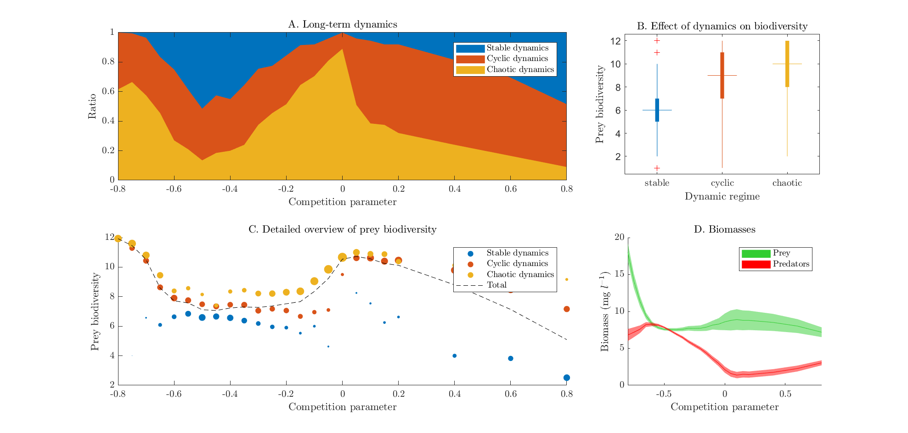

Results for a food web with predator and prey species. Food webs of different sizes show similar results (see 6.1 in Online Appendix). For each value of the competition parameter, randomly drawn ecosystems were simulated and classified as regular, cyclic or chaotic. Additionally, the number of non-extinct prey species after a stabilization run was registered. **Panel A**. Ratio of each dynamic regime vs. competition parameter. **Panel B**. Biodiversity vs. asymptotic regime. Box and whisker plot of the average number of non-extinct prey species grouped by asymptotic regime. **Panel C**. Average prey biodiversity vs. competition parameter. The dashed line shows the average number of non-extinct prey species grouped by competition parameter. The colored circles represent the average prey biodiversity of the simulations, additionally grouped by dynamical regime (stable, cyclic and chaotic). The relative size of the circles represents the ratio of simulations that led to regular or chaotic dynamics. **Panel D**. Average biomasses grouped by trophic level vs. competition parameter. The width represents standard deviation.

# Discussion

The asymptotic dynamics of our model are affected by the strength of intraspecific competition compared to interspecific competition. Interestingly, we find that competition close to neutrality significantly increases the chances of chaotic behaviour. This suggests that in a system with predation, neutrality-on-average at the competition level may increase the probability of complex dynamics if the species are not equally prone to predation. We also found a clear correlation between non-stable dynamics and a higher prey biodiversity, being chaotic dynamics more efficient than cyclic at harboring a higher biodiversity. This allows us to conclude that chaos improves the chances for a higher number of coexisting species in our model. These observations, when put together, suggest that the hypothesis of non-equilibrium (Huisman and Weissing 1999) and Hubbell’s hypothesis of neutrality are not completely independent (see figure 5).

In the spirit of mathematical modelling, we chose the simplest realization required for the effects to be observed. We explored the variation away from neutrality only along the stabilizing/destabilizing axis. We didn’t use Allee effect, nor noise, nor species-specific carrying capacities, and the functional form of each term has been chosen to account for satiation and saturation in the simplest possible ways. This opens the door to perform similar analyses in the future using more sophisticated models.

Both the competition and predation parameter sets were drawn from probability distributions. The interactions in our system can be interpreted as a weighted network with a high connectivity. In nature, trophic networks tend to show modular structure with various clusters (Thebault and Fontaine 2010). Our simplified model could be interpreted as representing one of those densely connected modules. It is known that the asymptotic behaviour of this kind of systems can be very sensitive to the parameters choice. In particular, introducing correlations between parameters can greatly modify the probabilities of chaotic attractors to be reached (see for instance Huisman et al. (2001), in response to the letter Schippers et al. (2001)). In the present paper we didn’t introduce any correlation, i.e., all our random parameters were drawn independently from the others. Studying the effect of different physiological scenarios (in the sense of Huisman et al. (2001), that is, constrains between the parameters) on the probabilities of chaos could be a continuation to this paper.

Due to the large number of simulations made, we had to rely on automatic methods for detecting chaos. Automatic detection of chaos by numerical methods has fundamental limitations, especially for high dimensional systems like ours. Most of them can be boiled down to the fact that, in general, numerical methods cannot distinguish robustly between long, complicated transients and genuine chaos. Our motivation to chose the Gottwald - Melbourne test (Gottwald and Melbourne 2009) was threefold: it discriminates between stable, cyclic and chaotic, it escalates easily to systems of higher dimensions, its computation is fast and it performs better than any other method we tried when compared to the visual inspection of the time series. Additionally, we expect that the massive number of simulated ecosystems will minimize the effect of possible wrongly classified time series. For these reasons, we think that our approach to chaos detection, despite being open to improvement, suffices to detect the overall patterns.

Our results suggest a fundamentally new way in which neutrality-on-average may promote biodiversity. In addition to weakening the forces of competitive exclusion (Scheffer, Nes, and Vergnon 2018), our analyses reveal that near neutrality may boost the chances for chaotic and cyclic dynamics. As chaos and cycles may facilitate super-saturated co-existence, our findings point to a potentially widespread mechanism of maintaining biodiversity.

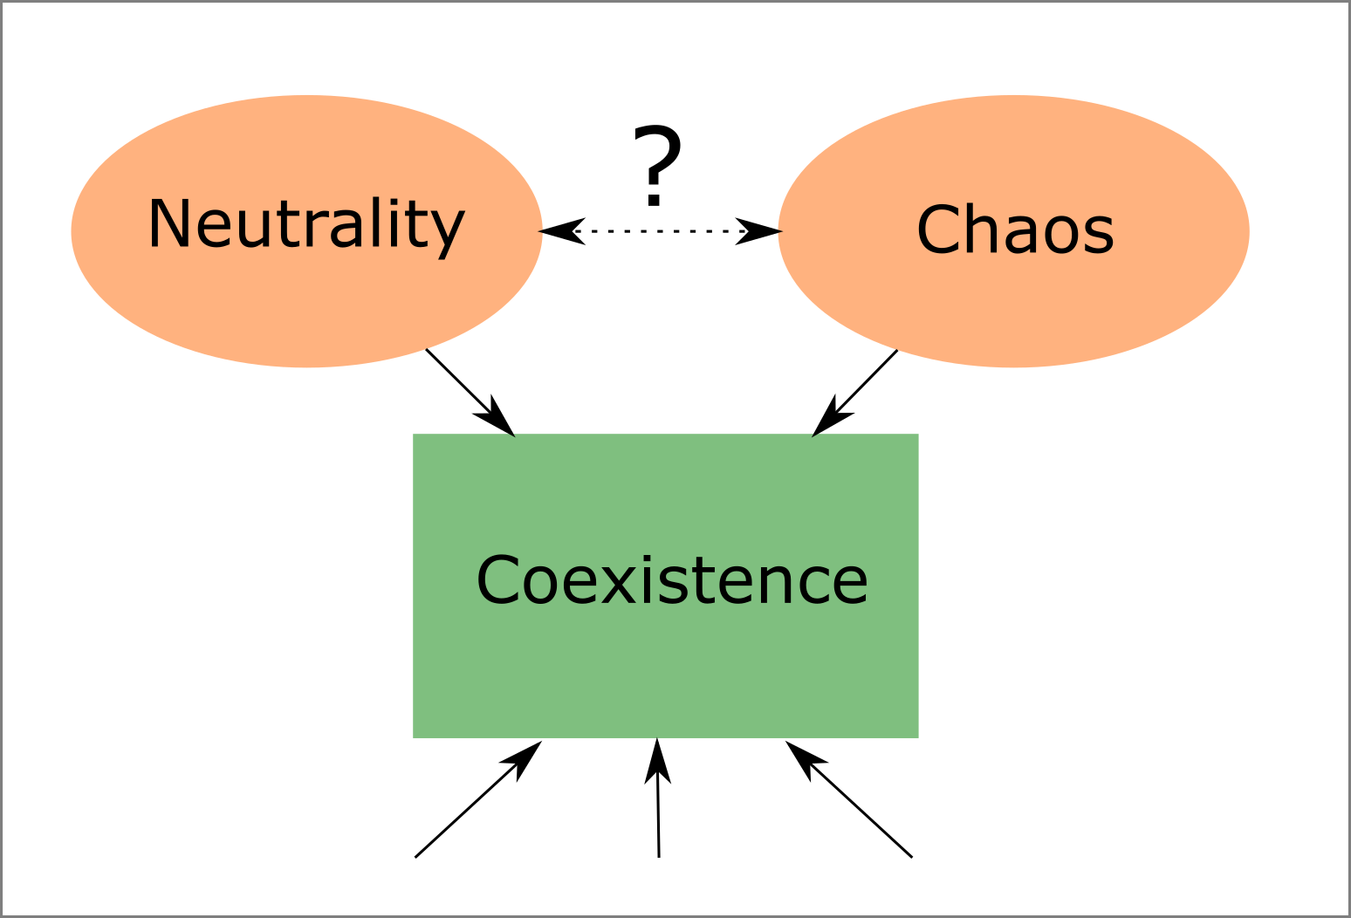

In our model, neutrality and chaos are not independent explanations of coexistence.

# Acknowledgments

The preliminary analysis of this model was performed using GRIND for Matlab (<http://www.sparcs-center.org/grind>). Additionally, we thank Tobias Oertel-Jäger, Sebastian Wieczorek, Peter Ashwin, Jeroen Lamb, Martin Rasmussen, Cristina Sargent, Jelle Lever, Moussa N’Dour, Iñaki Úcar, César Rodríguez and Sebastian Bathiany for their useful comments and suggestions.

This work was supported by funding from the European Union’s *Horizon 2020* research and innovation programme for the *ITN CRITICS* under Grant Agreement Number 643073.

# Online appendix

This is the Online Appendix for the paper:

Rodríguez-Sánchez P, van Nes EH, Scheffer M. *Neutral competition boosts chaos in food webs*.

## Results for food webs of different sizes

In the main body of the paper we focused our attention in families of food webs consisting of prey and predator species. In this section we show the results of the same analysis for food webs of different sizes.

### Probability of chaos grouped by number of species

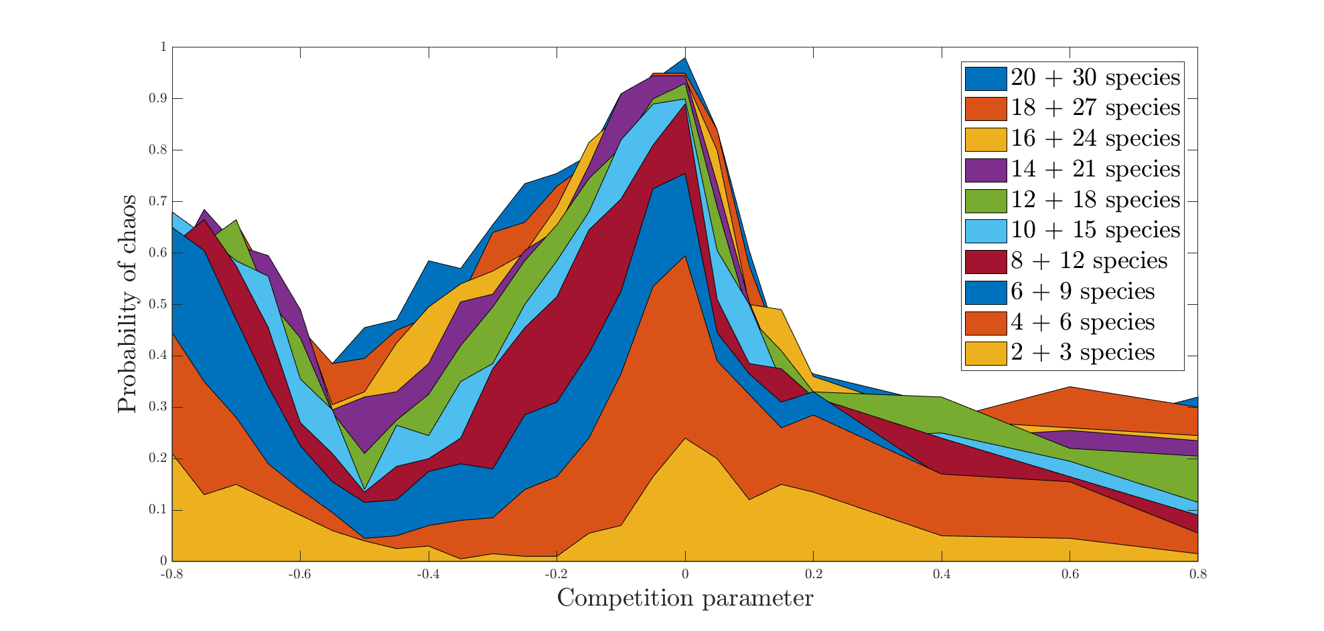

Probabilities of chaos vs. competition parameter for the whole set of simulations. The competition parameter is on the horizontal axis. The estimated probability of chaos is represented on the vertical one. Each panel corresponds to an ecosystem with a different number of interacting species. The exact number is shown in each box, as number of predator + number of prey species.

### Probability of each dynamical regime

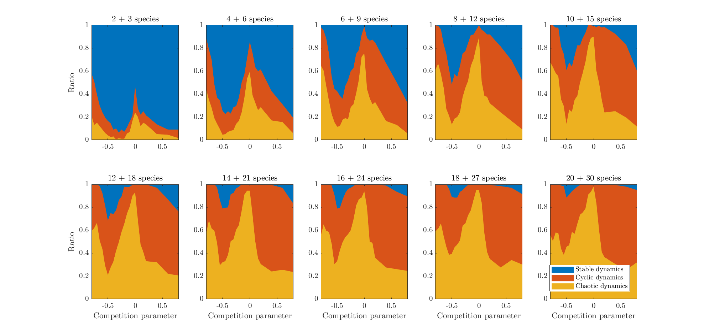

Ratio of each dynamical regime vs. competition parameter for the whole set of simulations. The competition parameter is on the horizontal axis. The system size is shown in each box, as number of predator + number of prey species.

### Biodiversity measurements

For each simulation, a biodiversity index was estimated as the number of prey species whose population was higher than a minimum threshold of , averaged respective to time.

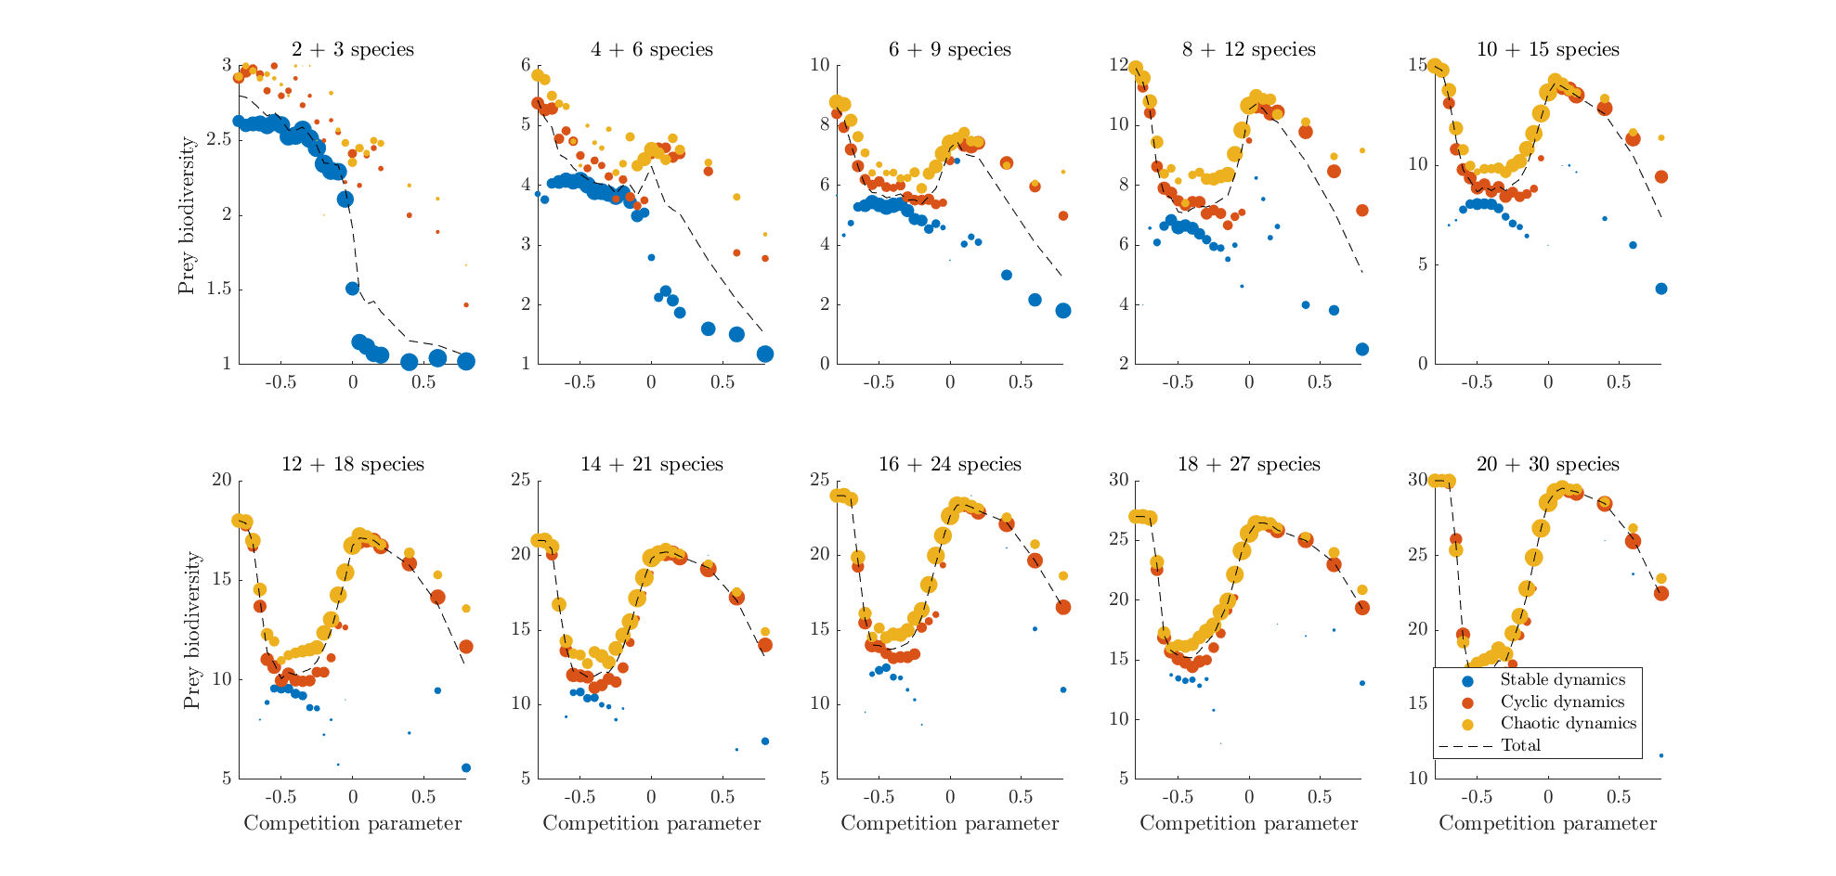

Average prey biodiversity vs. competition parameter. Each panel shows a food network of a different size. For each value of the competition parameter, 200 randomly drawn ecosystems were simulated. The dashed line shows the average number of prey species of these 200 simulations. The white circles represent the average prey biodiversity of those simulations who had chaotic dynamics, the black circles represent the same for non-chaotic dynamics. The relative area of the white to the black circles represents the ratio of chaotic to regular dynamics.

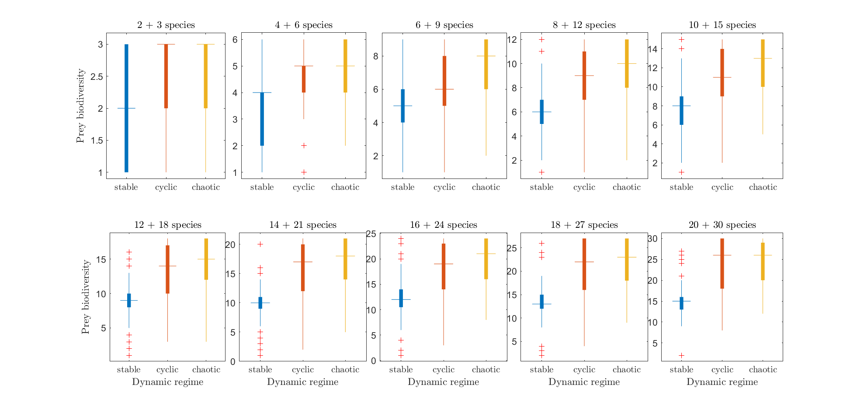

Box and whisker plot of the prey biodiversity, after being classified as regular or chaotic.

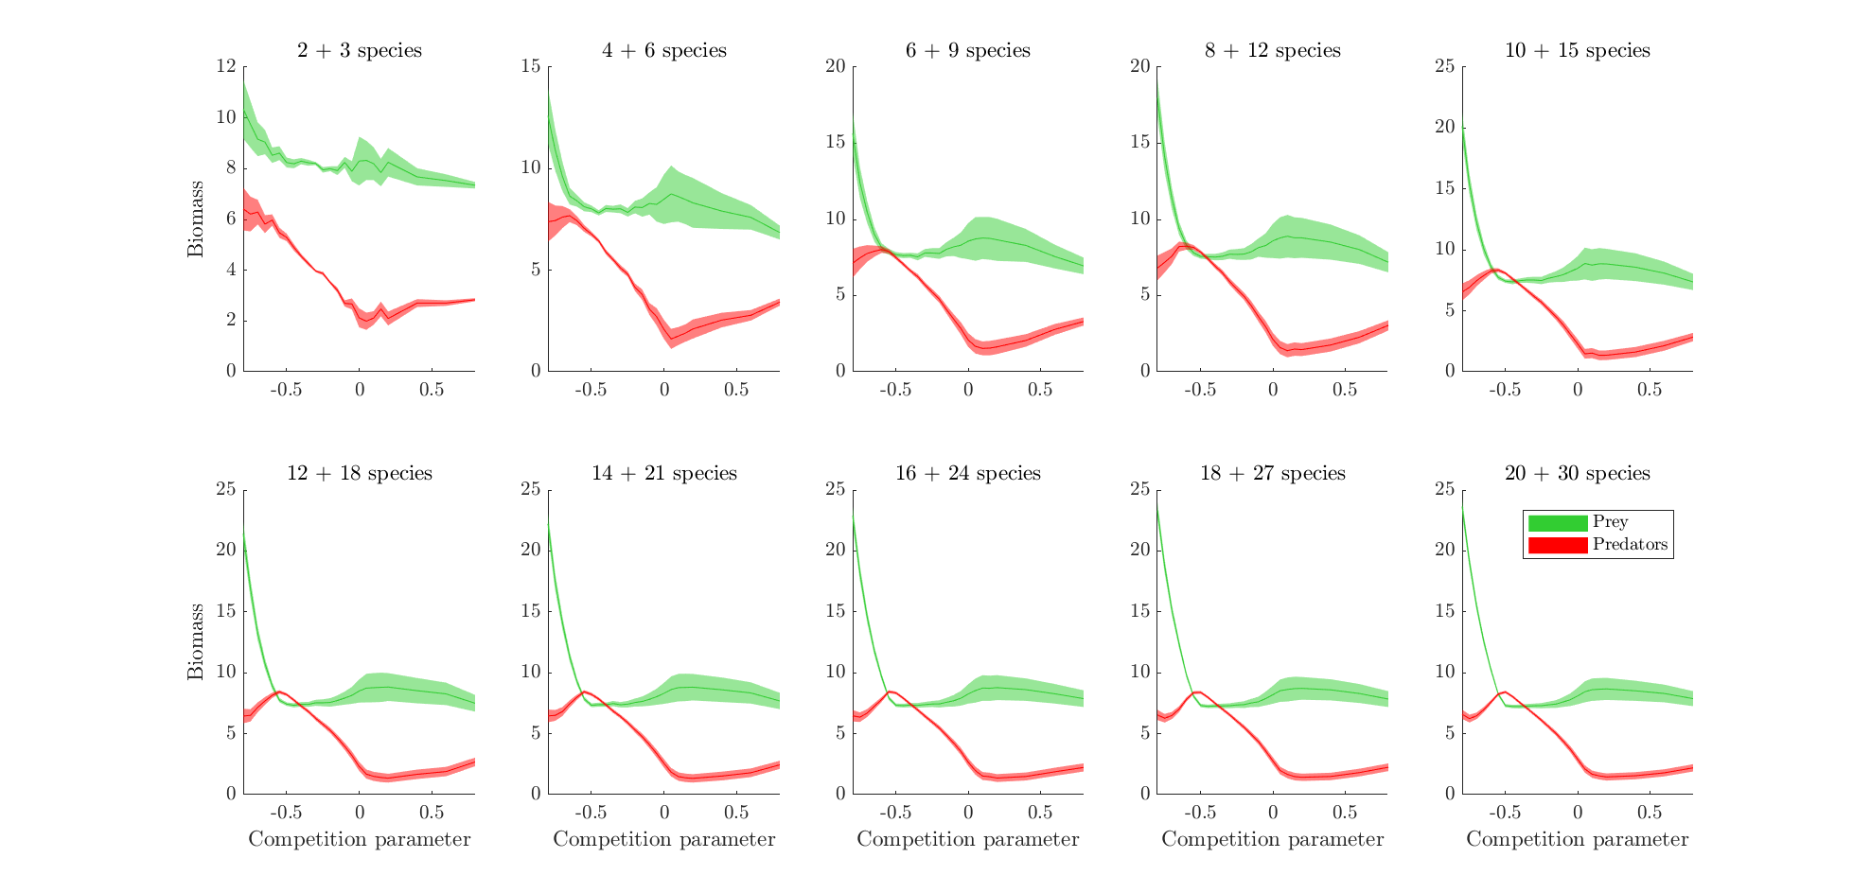

Average biomasses grouped by trophic level vs. competition parameter. The width represents standard deviation.

Armstrong, Robert A., and Richard McGehee. 1980. “Competitive Exclusion.” *The American Naturalist* 115 (2): 151–70. <https://doi.org/10.1086/283553>.

Benincà, Elisa, Jef Huisman, Reinhard Heerkloss, Klaus D. Jöhnk, Pedro Branco, Egbert H. Van Nes, Marten Scheffer, and Stephen P. Ellner. 2008. “Chaos in a long-term experiment with a plankton community.” *Nature* 451 (7180): 822–25. <https://doi.org/10.1038/nature06512>.

Dakos, Vasilis, E. Beninca, Egbert H van Nes, Catharina J M Philippart, Marten Scheffer, and Jef Huisman. 2009. “Interannual variability in species composition explained as seasonally entrained chaos.” *Proceedings of the Royal Society B: Biological Sciences* 276 (1669): 2871–80. <https://doi.org/10.1098/rspb.2009.0584>.

Edelstein-Keshet, Leah. 2005. *Mathematical Models in Biology*. Society for Industrial; Applied Mathematics. <https://doi.org/10.1137/1.9780898719147>.

Fort, H, M Scheffer, and E. Van Nes. 2010. “The clumping transition in niche competition: A robust critical phenomenon.” *Journal of Statistical Mechanics: Theory and Experiment* 2010 (5): P05005. <https://doi.org/10.1088/1742-5468/2010/05/P05005>.

Fort, Hugo, Marten Scheffer, and Egbert H. van Nes. 2009. “The paradox of the clumps mathematically explained.” *Theoretical Ecology* 2 (3): 171–76. <https://doi.org/10.1007/s12080-009-0040-x>.

Gottwald, Georg A, and Ian Melbourne. 2009. “On the Implementation of the 0-1 Test for Chaos.” *SIAM Journal on Applied Dynamical Systems* 8 (1): 129–45. <https://doi.org/10.1137/080718851>.

Hardin, Garrett. 1960. “The Competitive Exclusion Principle.” *Science* 131 (3409): 1292–7. <https://doi.org/10.1126/science.131.3409.1292>.

Hubbell, Stephen P. 2001. *The Unified Neutral Theory of Biodiversity and Biogeography*. Vol. 32. Princeton University Press. <https://doi.org/10.1016/S0006-3207(02)00228-8>.

Huisman, Jef, Anna M. Johansson, Eelke O. Folmer, and Franz J. Weissing. 2001. “Towards a solution of the plankton paradox: the importance of physiology and life history.” *Ecology Letters* 4 (5): 408–11. <https://doi.org/10.1046/j.1461-0248.2001.00256.x>.

Huisman, Jef, and Franz J Weissing. 1999. “Biodiversity of plankton by species oscillations and chaos.” *Nature* 402 (6760): 407–10. <https://doi.org/10.1038/46540>.

Hutchinson, G E. 1959. “Homage to Santa Rosalia or Why Are There So Many Kinds of Animals?” *The American Naturalist* 93 (870): 145–59. <https://doi.org/10.1086/282070>.

———. 1961. “The Paradox of the Plankton.” *The American Naturalist* 95 (882): 137–45. <https://doi.org/10.1086/282171>.

Nes, Egbert H. van, and Marten Scheffer. 2004. “Large Species Shifts Triggered by Small Forces.” *The American Naturalist* 164 (2): 255–66. <https://doi.org/10.1086/422204>.

Rodríguez-Sánchez, Pablo. 2018. “PabRod/Chaos-and-neutrality: Analysis script for "Neutral competition boosts chaos in food webs".” <https://doi.org/10.5281/ZENODO.1319590>.

Rosenzweig, M. L., and R. H. MacArthur. 1963. “Graphical Representation and Stability Conditions of Predator-Prey Interactions.” *The American Naturalist* 97 (895): 209–23. <https://doi.org/10.1086/282272>.

Scheffer, Marten, and Egbert H van Nes. 2006. “Self-organized similarity, the evolutionary emergence of groups of similar species.” *Proceedings of the National Academy of Sciences* 103 (16): 6230–5. <https://doi.org/10.1073/pnas.0508024103>.

Scheffer, Marten, Egbert H van Nes, and Remi Vergnon. 2018. “Toward a unifying theory of biodiversity.” *Proceedings of the National Academy of Sciences* 115 (4): 201721114. <https://doi.org/10.1073/pnas.1721114115>.

Scheffer, Marten, Remi Vergnon, Egbert H. van Nes, Jan G M Cuppen, Edwin T H M Peeters, Remko Leijs, and Anders N Nilsson. 2015. “The Evolution of Functionally Redundant Species; Evidence from Beetles.” Edited by Therésa M. Jones. *PLOS ONE* 10 (10): e0137974. <https://doi.org/10.1371/journal.pone.0137974>.

Schippers, Peter, Antonie M. Verschoor, Matthijs Vos, and Wolf M. Mooij. 2001. “Does "supersaturated coexistence" resolve the "paradox of the plankton"?” *Ecology Letters* 4 (5): 404–7. <https://doi.org/10.1046/j.1461-0248.2001.00239.x>.

Segura, A. M., C. Kruk, D. Calliari, F. García-Rodriguez, D. Conde, C. E. Widdicombe, and H. Fort. 2013. “Competition drives clumpy species coexistence in estuarine phytoplankton.” *Scientific Reports* 3 (1): 1037. <https://doi.org/10.1038/srep01037>.

Strogatz, Steven H. 1994. *Nonlinear Dynamics and Chaos: With Applications to Physics, Biology, Chemistry and Engineering*.

Thebault, E., and C. Fontaine. 2010. “Stability of Ecological Communities and the Architecture of Mutualistic and Trophic Networks.” *Science* 329 (5993): 853–56. <https://doi.org/10.1126/science.1188321>.

Vergnon, Remi, Remko Leijs, Egbert H. van Nes, and Marten Scheffer. 2013. “Repeated Parallel Evolution Reveals Limiting Similarity in Subterranean Diving Beetles.” *The American Naturalist* 182 (1): 67–75. <https://doi.org/10.1086/670589>.

Vergnon, Remi, Egbert H. van Nes, and Marten Scheffer. 2012. “Emergent neutrality leads to multimodal species abundance distributions.” *Nature Communications* 3 (May 2011): 663. <https://doi.org/10.1038/ncomms1663>.

Winter, C., T. Bouvier, M. G. Weinbauer, and T. F. Thingstad. 2010. “Trade-Offs between Competition and Defense Specialists among Unicellular Planktonic Organisms: the "Killing the Winner" Hypothesis Revisited.” *Microbiology and Molecular Biology Reviews* 74 (1): 42–57. <https://doi.org/10.1128/MMBR.00034-09>.

1. pablo.rodriguezsanchez@wur.nl
2. egbert.vannes@wur.nl
3. marten.scheffer@wur.nl